Processing an Employee Data Change – FTE Change Quick Reference Guide
Last Updated: 10/23/2018

This QRG outlines the Employee Data Change – FTE Change process of updating an employee’s FTE Status

Contents
When to process an Employee Data Change – FTE Change 1
Employee Data Change – FTE Change Process 1
Access SuccessFactors 1
Searching for an Employee 2
Taking Action 2
Updating Job Information 4
Updating Work Schedule 5
Updating Compensation Information 6
Submitting the Change 6

When to process an Employee Data Change – FTE Change
Initiators will process an FTE change when a business or personal need arises to increase or reduce an employees FTE (i.e. taking an employee from 100% to 50%).

Employee Data Change – FTE Change Process
The Initiator will process the Employee Data Change – FTE Change. Once complete, it will route through workflow to the Budget Approver and central Payroll/Time.

Access SuccessFactors
Visit OneCampus and select Employee Launchpad or from the Employee Self-Service web page click SuccessFactors  Log in using Purdue Career Account ID and Password. | https://one.purdue.edu/  https://www.purdue.edu/hr/global/pgnew.php  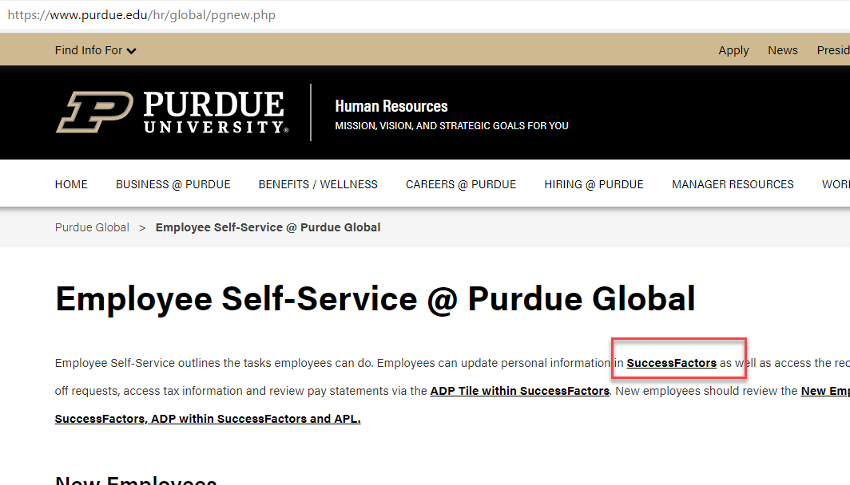
From the SuccessFactors home page, type the name of the employee in the Search field on the navigation bar.

Searching for an Employee
As the employee’s name is being typed, multiple matches will be displayed.  Scroll down to the correct employee’s name and click to select. | 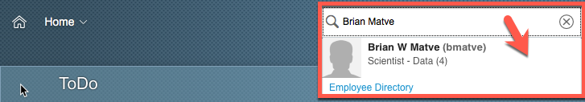
This will display the employee’s Employee File. | 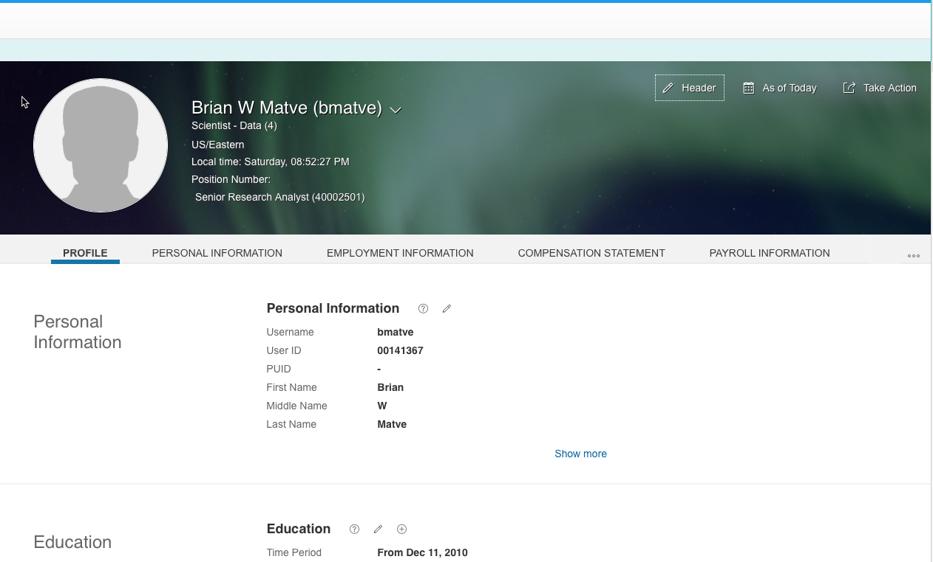

Taking Action
There are two options available to begin processing an Employee Date Change – FTE Change.  The first option is found on the SuccessFactors home page.  Once the employee has been located, hover over their name to view their employee information on a separate pop up window.  Next, click Take Action to display action options. | 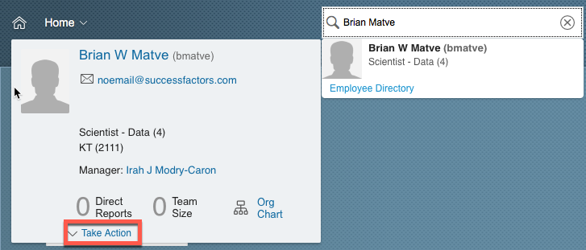
Once the action options are  displayed, select Change  Job and Compensation  Info to begin processing the  Employee Date Change –  FTE Change. | 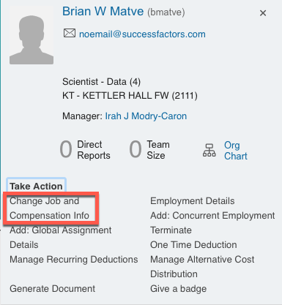
The second option is found on the employee’s Employee Profile.  Click Take Action to display action options. | 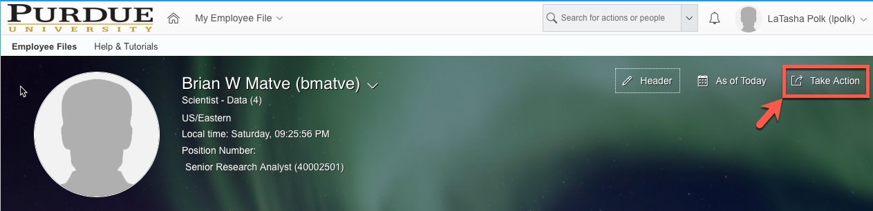
Once the action options are displayed, select Change Job and Compensation Info to begin processing the Employee Data Change – FTE Change.
Click the check boxes next to Job Information and Compensation Information.  Next, manually input the date (mm/dd/yy) that the change should take effect or click the Calendar icon to display a calendar that can be used to choose the date.  Click the day the change should take effect to populate the date field. | 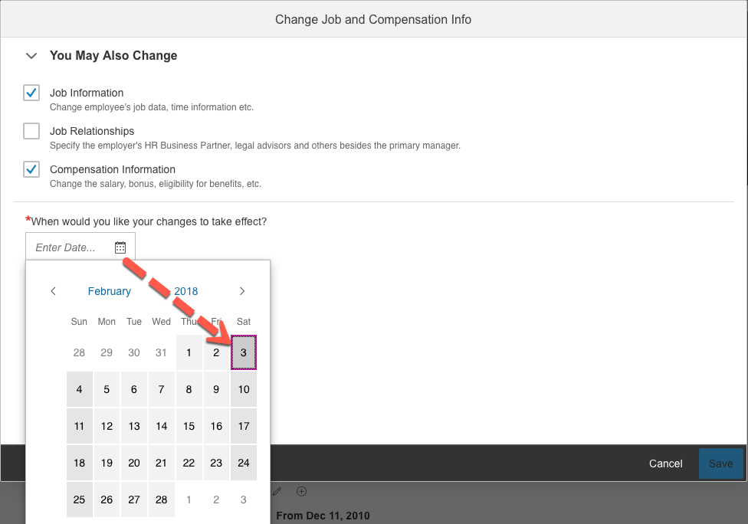

Updating Job Information
Scroll to Job Information header until “Show more” is displayed and click it to view the additional fields.

Manually change the Standard Weekly Hours.
Note: Do not change FTE – this will auto-populate.

Verify appropriate option is selected in is Eligible for Benefit (Yes/No) field.
Considerations:
- FTE will be below 0.5: NO
- FTE will be above 0.5: YES
- Concurrent employees: Consider full FTE.
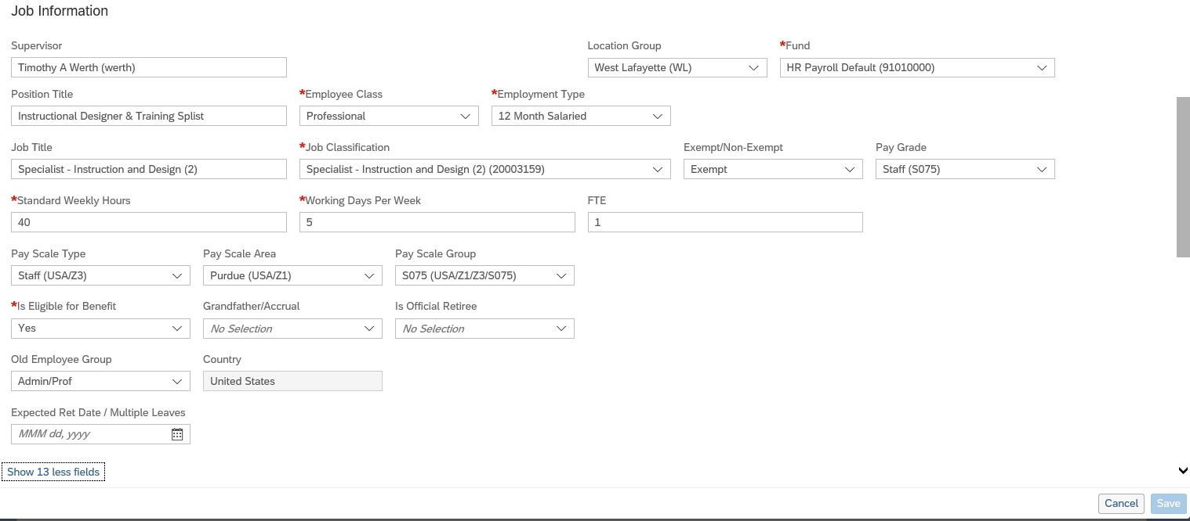

Updating Work Schedule
Scroll down to the Time Information section.
Adjust/verify the Work Schedule.
Important notes for assigning/creating schedules for individuals with less than 1.0 FTE
- Non-exempt employees: The number of hours of the work schedule assigned to / created for the employee must match the individual’s FTE (based on a 40 hour workweek). Failure to properly assign/create the schedule will result in pay errors as pay, including holiday pay, is derived from the schedule for the individual. It also will impact Time Off requests. Non-exempt employees who are assigned the Webclock time entry method should be assigned the AdHoc Monday through Friday (AdHocMF) schedule. It is important to review the available schedules before building a custom schedule.
- Fiscal Year (FY) Exempt employees: Choose schedule Exempt – Monday to Friday – 8 hours, regardless of FTE. Additional standard options for FY schedules will be built after the initial SuccessFactors implementation.
- Academic Year (AY) Exempt employees: Choose the AY schedules for the appropriate campus (AY-NW, AY-FW, AY-WL). Failure to properly assign/create the schedule will impact the individual’s ability to request Time Off in multiple day increments.
- Note: If the work schedule is “ad hoc,” it is likely that no edit is needed.

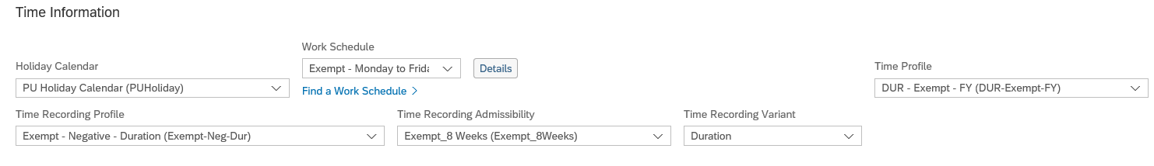

Updating Compensation Information
Scroll down to the Compensation Information header.
- Update the Pay Component field by reselecting its current contents to repopulate the associated fields with the correct information associated with the previous changes. (e.g. Frequency field updates to the correct frequency)
- For salaried employees, update the Amount field
  - For hourly employees, the FTE change automatically reduces their annual salary and the pay is taken care of without manually changing it.
Review the information that populates for accuracy.
Click Save to submit for approval.
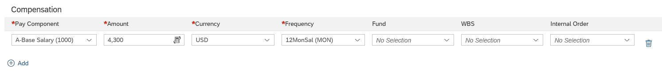

Submitting the Change
Click Save at the bottom right corner of the Change Job and Compensation Info screen.
The Warning box appears.  Click Correct if edits are needed.  Click Proceed if the changes are ready for approval. | 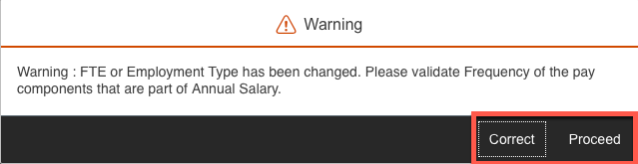
If Proceed is selected, a confirmation box will appear.  Enter any comments associated with the FTE Change in the comment box.  Click Confirm to trigger workflow to Budget Approver.  Email notification is sent to the all workflow participants.  Note: Click Show workflow participants to display the individuals responsible for reviewing and approving the FTE Change. | 